|  |  |  |  |  |  |  |  |  |  |
| --- | --- | --- | --- | --- | --- | --- | --- | --- | --- |
| **Quantity of Labor** | **Quantity of Sweatshirts** | **Fixed Cost** | **Variable Cost** | **Total Cost** | **Average Fixed Cost** | **Average Variable Cost** | **Average Total Cost** | **Marginal Product of Labor** | **Marginal Cost** |
| **0** | 0 | 2000 | 0 | 2000 | - | - | - | - | - |
| **1** | 300 | 2000 | 1000 | 3000 | 6.67 | 3.33 | 10 | 300 | 10 |
| **2** | 800 | 2000 | 2000 | 4000 | 2.5 | 2.5 | 5 | 500 | -5 |
| **3** | 1200 | 2000 | 3000 | 5000 | 1.67 | 2.5 | 4.17 | 400 | -0.83 |
| **4** | 1400 | 2000 | 4000 | 6000 | 1.43 | 2.86 | 4.29 | 200 | 0.12 |
| **5** | 1500 | 2000 | 5000 | 7000 | 1.33 | 3.33 | 4.66 | 100 | 0.37 |



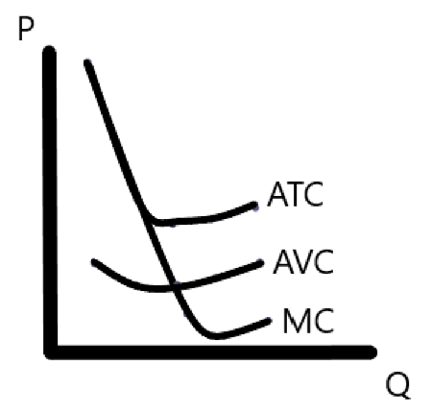



The most efficient production level is at an output of 1200 sweatshirts



Accounting profit = $45,600

Economic profit = -$17,400

You should not open the store because the economic profit is negative



|  |  |  |  |  |  |  |  |  |
| --- | --- | --- | --- | --- | --- | --- | --- | --- |
| **Q** | **FA-TC** | **FA-ATC** | **Q** | **FB-TC** | **FB-ATC** | **Q** | **FC-TC** | **FC-ATC** |
| **1** | 60 | 60 | **1** | 11 | 11 | **1** | 21 | 21 |
| **2** | 70 | 35 | **2** | 24 | 12 | **2** | 34 | 17 |
| **3** | 80 | 26.67 | **3** | 39 | 13 | **3** | 49 | 16.33 |
| **4** | 90 | 22.5 | **4** | 56 | 14 | **4** | 66 | 16.5 |
| **5** | 100 | 20 | **5** | 75 | 15 | **5** | 85 | 17 |
| **6** | 110 | 18.33 | **6** | 96 | 16 | **6** | 106 | 17.67 |
| **7** | 120 | 17.14 | **7** | 119 | 17 | **7** | 129 | 18.43 |

Firm A experiences Economies of Scale, both Firm B and Firm C experience Diseconomies of Scale.

1. I would choose Firm B if I had to produce 3 units because Firm B has the lowest Average Total Cost

a.

|  |  |  |  |  |  |  |  |  |
| --- | --- | --- | --- | --- | --- | --- | --- | --- |
| **Q** | **FC** | **VC** | **TC** | **AFC** | **AVC** | **ATC** | **MC** | **MS** |
| **0** | 5 | 0 | 5 | - | - | - | - | 0 |
| **1** | 5 | 5 | 10 | 5 | 5 | 10 | 5 | 100 |
| **2** | 5 | 8 | 13 | 2.5 | 4 | 6.5 | 3 | 200 |
| **3** | 5 | 13 | 18 | 1.67 | 4.33 | 6 | 5 | 300 |
| **4** | 5 | 20 | 25 | 1.25 | 5 | 6.25 | 7 | 400 |
| **5** | 5 | 29 | 34 | 1 | 5.8 | 6.8 | 9 | 500 |
| **6** | 5 | 40 | 45 | 0.83 | 6.67 | 7.5 | 11 | 600 |

b.

|  |  |  |
| --- | --- | --- |
| **Price** | **Quantity Demanded** | **Market Supply** |
| $12 | 300 | 300 |
| 10 | 500 | 500 |
| 8 | 800 | 800 |
| 6 | 1200 | 1200 |
| 4 | 1800 | 1800 |

1. Market price = $10, profit = $5000